MEEM 5990

Getting Data in the Lab

Spring 2016

**In-class exercise**

Part 1

1. Create a new VI
2. Build a VI so that it looks like this. The DAQ functions are on the Measurement I/O->NI-DAQmx palette. The purple drop-downs are for *polymorphic VIs*, which are a collection of VIs that all have similar functionality, but slightly different datatypes. Make sure to select the correct instance (e.g. “AI Voltage” and “Analog DBL 1Chan 1Samp”).

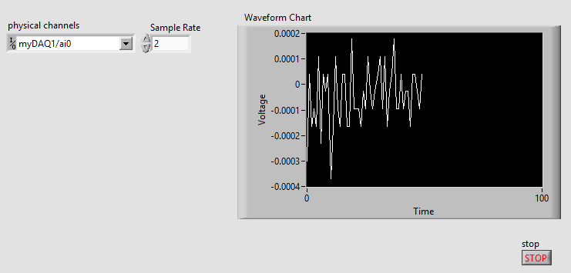

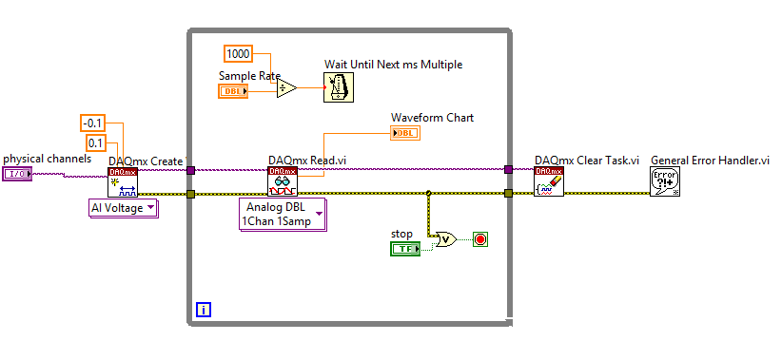

1. Set the “physical channel” to channel 0 of your myDAQ (or other device, as appropriate)
2. Set your sample rate to something “reasonable.” A value of 10 or less is good.
3. Save the VI as “SoftwareTimedVoltageAcq.vi”
4. Run the VI to ensure that it works.
5. Connect a thermocouple up to your DAQ device. Ensure that you wire the correct leads to the + and – terminals.
6. Run the VI. Try moving the thermocouple around to places with various temperatures and watch the response.

Part 2

In part 2 we will modify the VI to return temperature instead of voltage

1. Create a sub VI with the following inputs: DBL “Measured Voltage”, DBL “CJC Temperature”, and outputs DBL “Temperature.” Also create standard error in and error out clusters. The error cluster could be used, for example, to do range checking, but we will not do that in this exercise.
2. Implement the following equations to convert your measured voltage into a temperature, accounting for the CJC temperature. You will find the “Polynomial Evaluation.vi” VI to be helpful.

The following will also be helpful:

<http://myweb.astate.edu/sharan/PMC/Labs/Measuring%20Temperature%20with%20Thermocouples.pdf>

However, I found the equations to be difficult to understand in that document. Here they are more clearly:







Note that the table values are in microvolts/T^n

1. Place your subVI on your main VI and wire it. You will need to create a control or constant for the CJC temperature input.
2. Test the VI.

Part 3

1. Save the main VI as “SoftwareTimedTCAcqBuilt-in.vi:
2. Delete your subVI from the main VI.
3. Replace the subVI with the LabVIEW function “Convert Thermocouple Reading.vi”
4. Curse at your professor for making you do all that work in Part 2 unnecessarily.
5. Apologize to your professor for cursing at him, realizing that he was trying to teach something applicable to many sensors. LabVIEW does not have a built-in function for most of these.

Part 4

1. Reopen SoftwareTimedVoltageAcq.vi
2. Save it as SoftwareTimedDAQmxTCAcq.vi
3. Change the polymorphic Create DAQ Task.vi to have AI Temp TC type.

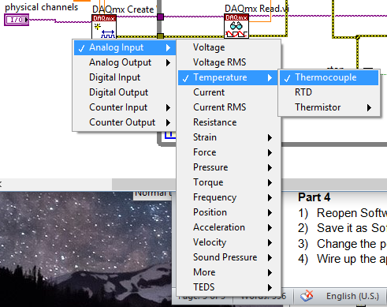

1. Wire up the appropriate input terminals and modify the minimum and maximum range to be expressed in temperature.
2. Note that this option may work for many sensor types, but will not work for everything.
3. Save and run the VI.